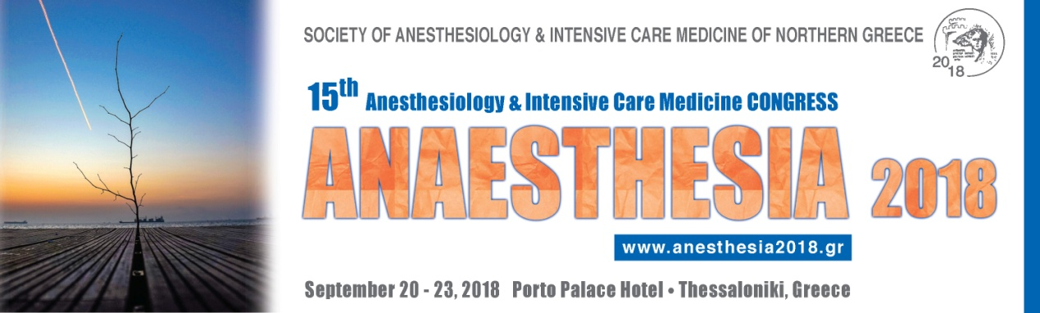

SPECIAL PREREGISTRATION & ACCOMMODATION FEE
for Serbian colleagues

(until 15/07/2018)

1. PACKAGE I: 180 € (sharing room with other participant)
The above rate includes:
- One & a half day (Friday afternoon & Saturday) registration
- Certificate of attendance
- Congress kit
- Coffee breaks & light lunch on Saturday
- 2 nights’ accommodation at Porto Palace- Congress Hotel (Friday & Saturday), per person in double, breakfast included.
- Ticket for the Farewell dinner on Saturday evening

2. PACKAGE II: 40 €
The above rate includes:
- One & a half day (Friday afternoon & Saturday) registration
- Certificate of attendance
- Congress kit
- Coffee breaks & light lunch on Saturday
- Ticket for the Farewell dinner on Saturday evening
- Accommodation at participants’ expend and choice of overnight stay (participant is free to arrange his/her accommodation him/herself)

