Global CERTAIN Course

By Mayo Clinic METRIC^{ePM} Group (Multidisciplinary Epidemiology and Translational Research in Intensive Care Emergency and Perioperative Medicine)

Checklist for Early Recognition and Treatment of Acute Illness (CERTAIN) is a quality improvement program that offers a systematic approach to perform an initial assessment and ongoing evidence based management of the critically ill or injured patient.¹ In the last decade, our team has successfully implemented CERTAIN in a network of 36 hospitals worldwide (www.icertain.org) using bedside decision support tools and web-based remote simulation and coaching. Thus far >1000 physicians and nurses completed CERTAIN training with >5,000 patients enrolled globally.^{1,2} Preliminary report of the quality improvement research study showed CERTAIN implementation was feasible and was associated with better adherence to basic critical care processes, decrease in complications, shorter ICU and hospital lengths of stay, and lower mortality.³

Healthcare professionals have long recognized the need for lifelong learning throughout their career in order to deliver the best possible care to patients they serve. Due to the current fast pace of development in science and technology, conventional conferences are not sufficient to translate scientific and medical knowledge to clinicians that would ultimately benefit patients. Moreover, the constraints of distance and training pose major barriers for large-scale adoption of best critical care practices, particularly in low- and middle-income countries. With the vision to minimize preventable death, disability and expensive complications in their sickest patients, Mayo Clinic METRIC faculty has launched CERTAIN course series dedicated to helping physicians and nurses implement meaningful change in acute care hospitals.

- CERTAIN Course
  - Delivered by Mayo and regional faculty on selected US and international locations in partnership with host institution or organization
    - Pre-course needs assessment: Collaborative review of patient care demands, critical care environment, and goals of the participating healthcare team to customize course content, delivery to maximize impact
    - Expert lectures (on-site, remote and/or recorded) on key domains: standardization, implementation science, informatics, quality improvement, education and research
    - Hands on workshop containing mentored experiential learning at local simulation facility
      - Admission module
      - Rounding module
      - CERTAIN checklist and decision support
      - Point of care ultrasound as a stethoscope
    - Panel discussion on key topics including shared decision making, prevention of nosocomial complications, end of life care etc.
    - Post-course assessment, commitment to change, and learner satisfaction survey
    - Participants eligible to become recognized as CERTAIN Trainer
  - Future courses: Croatia May 2019, Slovenia, June 2019, China, June 2019, Rochester MN, USA September 2019
- One year Tele-Education Program
  - Complete CERTAIN course as a prerequisite
  - 40 sessions of video interactive case based sessions that will transform your ICU practices in 1 year
  - By using asynchronous online learning, remote simulation training, competency assessment, and in–situ coaching, Tele-Education program is designed to maximize education efficiency and effectiveness, and ultimately improve meaningful patient outcomes.
  - Eligible to be recognized CERTAIN ICU
Based on the 10 years of experience to design, develop and implement innovation solutions to transform ICU practices in hospitals around the world, CERTAIN Program is focused on standardized approach to acutely ill and injured patients.⁴ The course objectives include: the reason and need to change of current practice of acute care, CERTAIN approach to make the change; tools and technology to enable the change, including clinical informatics and simulation; patient engagement for shared decision marking; communication skills for the clinical team and family members; patient safety and quality improvement principles; change management and implementation science; and clinical research. Participants will also learn from the practical experience of an international group of faculty experts, who have implemented this program in the hospitals across five continents.

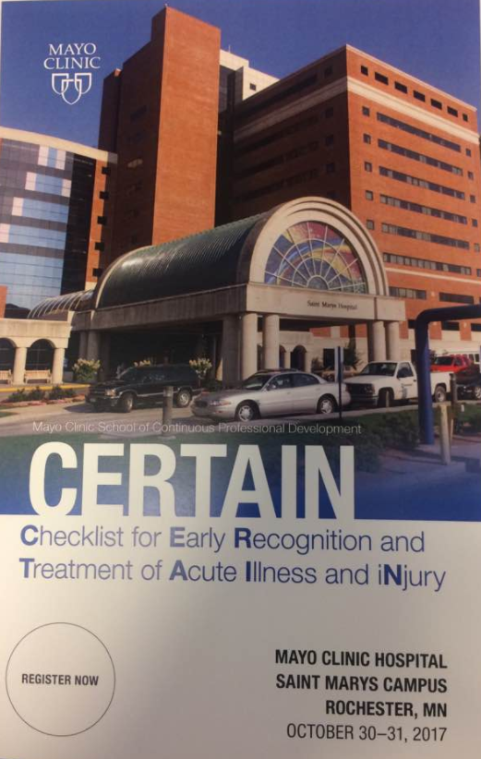
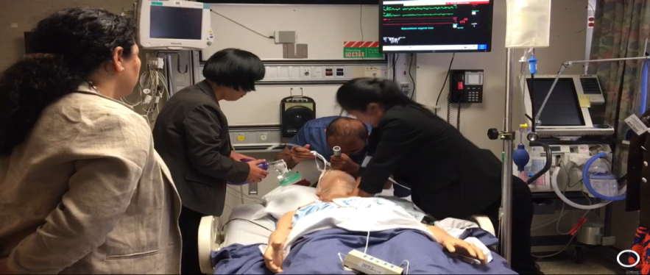

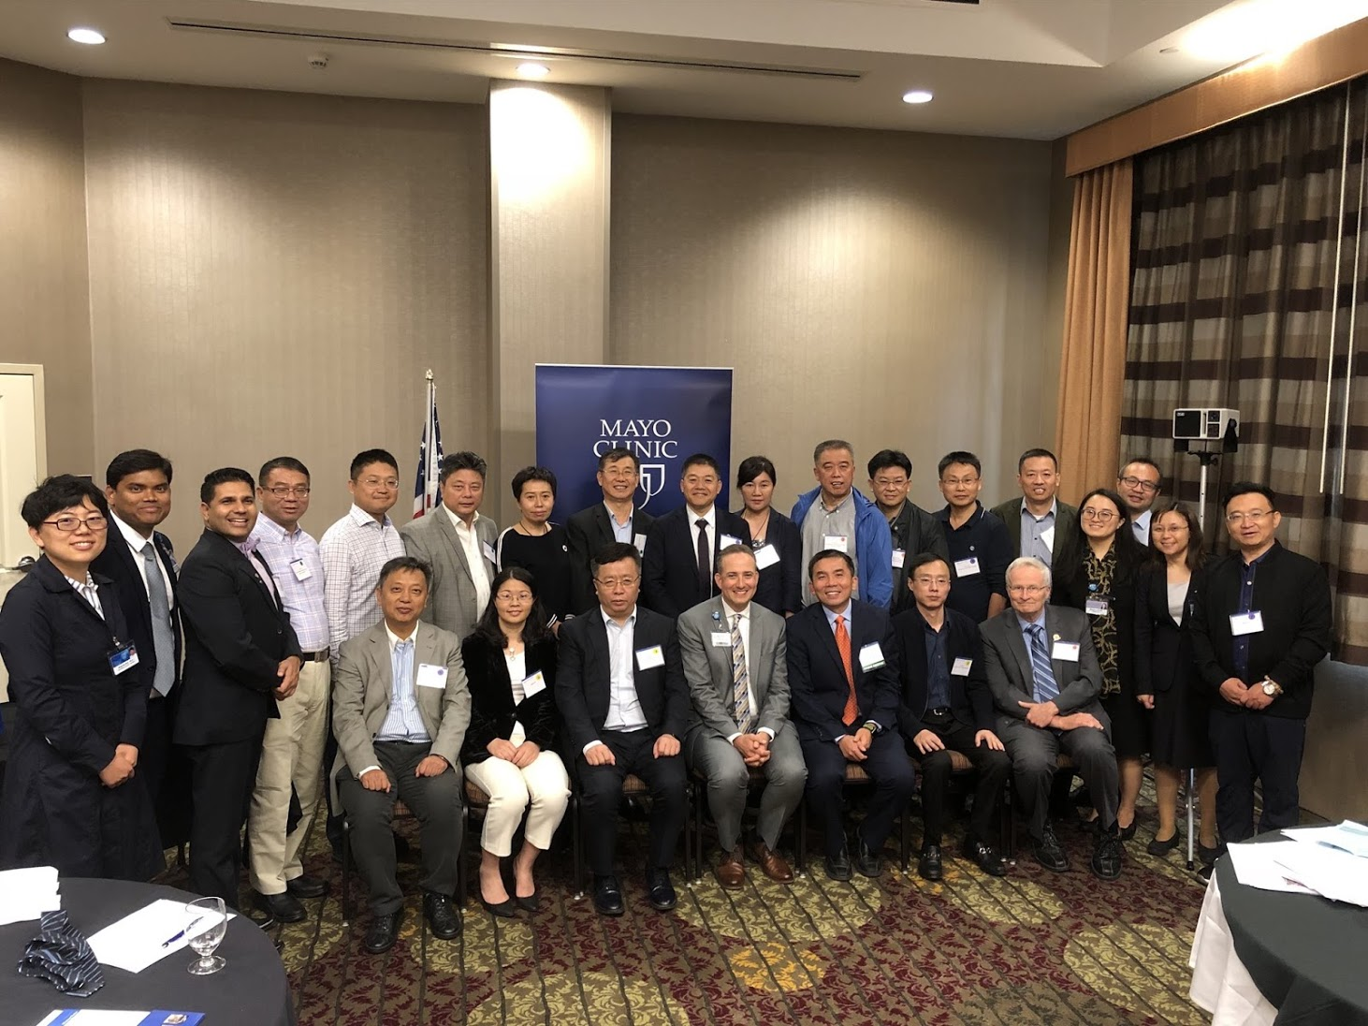

References:
1. Vukoja M, Kashyap R, Gavrilovic S, Dong Y, Kilickaya O, Gajic O. Checklist for early recognition and treatment of acute illness: International collaboration to improve critical care practice. World J Crit Care Med 2015; 4(1): 55-61.
2. Shao M, Kashyap R, Arguello LG, et al. Remote simulation training with CERTAIN checklist in 11 countries. Critical Care Medicine 2015; 43(12): 59.
3. Vukoja et al. Society of Critical Care Medcine 49th Critical Care Congress 2019;
4. CERTAIN Course 2017. https://ce.mayo.edu/emergency-medicine/content/certain-2017#group-tabs-node-course-default2 (accessed March 27, 2018.

